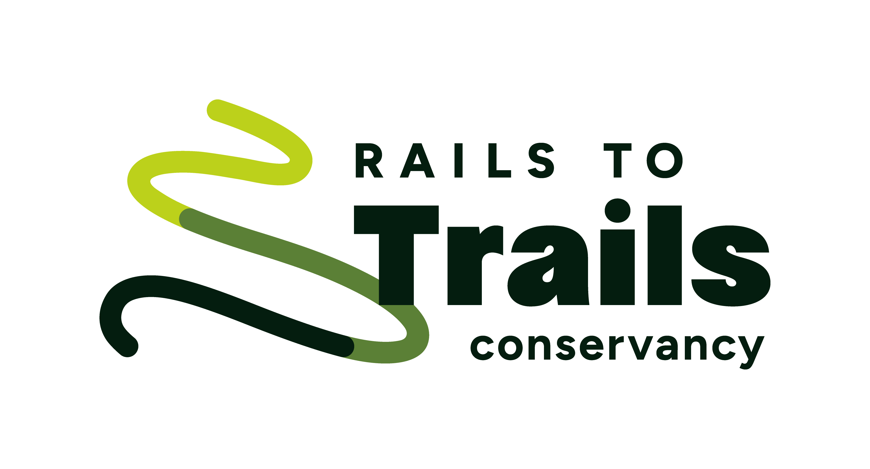

For Immediate Release: December 11, 2025
Contact: Patricia Brooks, patricia@matchmapmedia.com, 202.351.1757

Rails to Trails Conservancy Honors Groundwork Jacksonville’s
Kay Ehas as the Nation’s 2025 Trail Champion

Ehas is recognized for her community-driven approach in developing the Emerald Trail, Jacksonville, Florida’s 30-mile trail system, building social, economic and environmental resilience regionwide

WASHINGTON—Rails to Trails Conservancy has named Kay Ehas, chief executive officer of Groundwork Jacksonville, the 2025 Doppelt Family Rail-Trail Champion for modeling a community-driven approach anchored in public-private partnership to develop the Emerald Trail in Jacksonville, Florida.

“Kay Ehas is modeling an approach to trail development that seamlessly brings together residents, regional leaders and private investment in partnership. Her leadership is building more than infrastructure. It’s building social capital and civic participation that will make the trail network successful and will endure long after this project is complete,” said Ryan Chao, president of RTC.

Ehas spearheads the work at Groundwork Jacksonville, the city of Jacksonville’s nonprofit partner in developing the Emerald Trail and restoring McCoys Creek and Hogans Creek. The Emerald Trail is a 30-mile bicycle and pedestrian trail and linear park system that will connect 14 historic neighborhoods and downtown Jacksonville to local and regional trails, parks, schools, businesses, transit and other destinations.

The Emerald Trail Master Plan was adopted by the Jacksonville City Council in early 2019 and construction is anticipated to be completed in the next nine years. The LaVilla Link, the first segment of the Emerald Trail, opened in May 2024 and has been foundational in demonstrating the impact that this walking and biking route will have across the region.

“The vision of the Emerald Trail is about more than a trail. We see the trail as a catalyst to neighborhood revitalization and economic development,” said Ehas. “We have already seen major private investment happening—even before the first mile was ever built—and residents’ physical and mental health will improve by encouraging people to connect with nature and with one another.”

The Emerald Trail will deliver a boon to the local economy, promoting neighborhood revitalization, entrepreneurial opportunities and tourism while addressing environmental concerns in the region—all priorities for residents as well as the city. The Emerald Trail includes environmental remediations of contaminated lands and the restoration of both McCoys Creek and Hogans Creek, which are integrated with the trail network. Currently, 70% of residents living within Jacksonville’s urban core are considered low income and rank in the lower third and fourth quartiles for chronic illness.

“The strategy to advance the trail network starts with an important question: As residents, what do we want the Emerald Trail to be?” said Ehas. “We ensure residents have a seat at the table, a voice in shaping what the future of their neighborhood looks like, and a role in bringing that future to life. That’s how we build trust and a stronger, healthier community.”

The trail is included in the North Florida Transportation Planning Organization’s Northeast Florida Regional Multi-Use Trails Master Plan as a connection to the planned Core-2-Coast trail and is part of the 3,000-mile developing East Coast Greenway. Learn more about Ehas’s work and the Emerald Trail at groundworkjacksonville.org.

Since 2011, the Doppelt Family Rail-Trail Champions Award has honored individuals from across the country who have made significant contributions to the rail-trail movement through their hard work, volunteerism and support—in short, those who have gone above and beyond in the name of trails. Awardees include volunteers, agency officials, members of Congress and state legislatures, and governors.

The award is named in honor of the late rail-trail philanthropist Jeffrey L. Doppelt. Learn more about the nation’s Rail-Trail Champions: rtc.li/trail-champions.

Rails to Trails Conservancy is the nation’s largest trails organization—with a grassroots community more than 1 million strong—dedicated to building a nation connected by trails, reimagining public spaces to create safe ways for everyone to walk, bike and be active outdoors. Connect with RTC at railstotrails.org and @railstotrails on Facebook, Twitter and Instagram.

—30—

